[PSoC 4 Pioneer Kit Community Project#02 - CapSense Slider](http://www.element14.com/community/message/75477#75477/l/psoc-4-pioneer-kit-community-project02--capsense-slider)

On the 2nd day of our ***100 Projects in 100 Days*** community effort, I am posting one of the PSoC 4 Pioneer Kit's bundled example projects.

This is a very simple yet effective CapSense® demo that implements a 5-segment slider, like the one available on the Pioneer kit.

Moving your finger across the capacative touch slider on the board, you will observe the multicolor LEDs gradually changing color from red to green. These LEDs are driven by the PWM Component.

Project Schematic:

[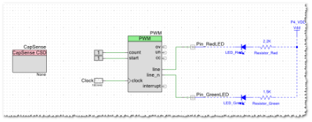](http://www.element14.com/community/servlet/JiveServlet/showImage/2-75477-144236/project02.png)

                            (Actual PSoC Creator project schematic "TopDesign.cysch")

*[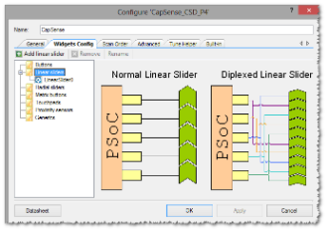](http://www.element14.com/community/servlet/JiveServlet/showImage/2-75477-144237/project02CSD.png)*

    (CapSense Component Customizer - Implementing a Capacitive Touch Slider)

Hardware Connections (all internal to the board, no external connections required):

* 5-segment Slider - P1[1] - P1[5]
* Green LED - P0[2]
* Red LED - P1[6]

Software Setup:

* See steps #1 - #6 from the main post [here](http://www.element14.com/community/message/75417#75417/l/100-projects-in-100-days)
* Main.C - This example project implement simple firmware in the project's main.c as shown below (already completed in the example project). The code implmented scans the CapSense slider, then updates the PWM's PulseWidth with the slider value.

[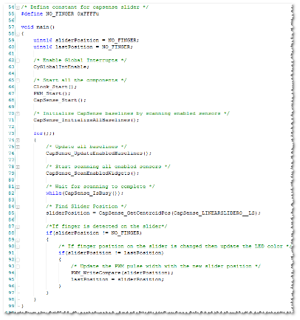](http://www.element14.com/community/servlet/JiveServlet/showImage/2-75477-144238/project02main.png)

                                      ( Project firmware - main.c )

<http://www.element14.com/community/message/75477>